Day 5

.net Project configured and run:
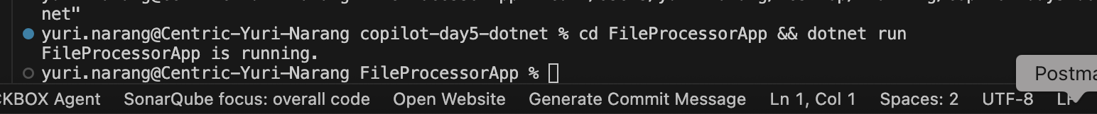

Run tests:
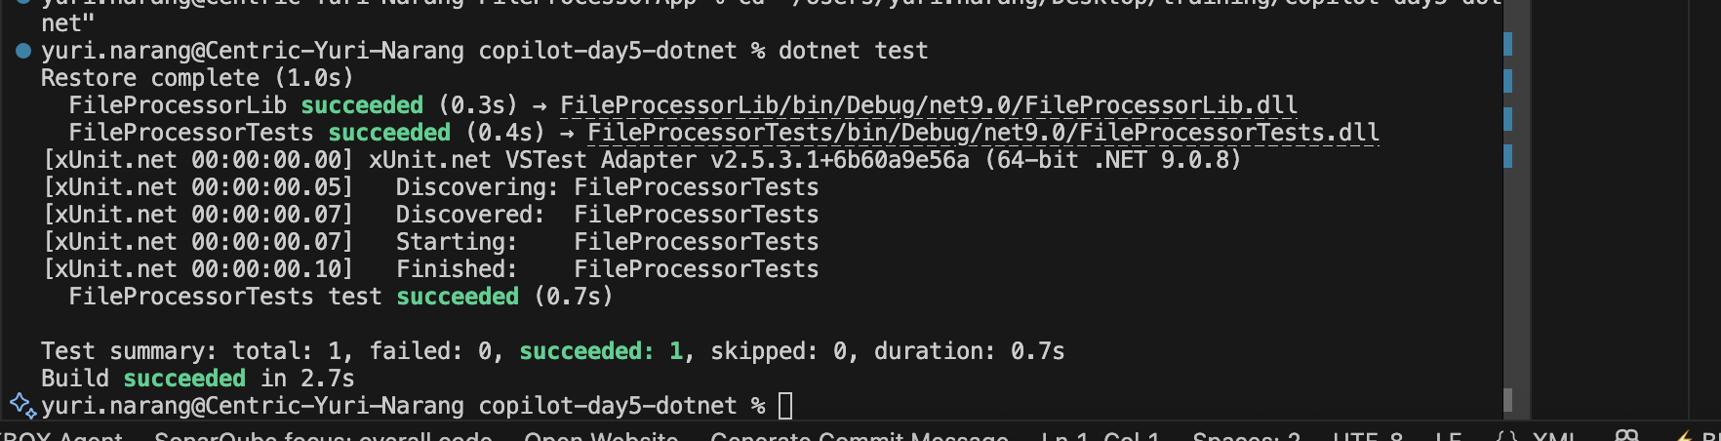

I have given this prompt:
Please help me in Convert this blocking IO controller into an async streaming implementation and include a unit test or
integration test
Copilot said:
I need to convert the blocking IO in FileProcessor.GetFileLength to an async streaming implementation using StreamReader, add an async unit test, and update the app to use it asynchronously. Can I proceed with these changes?

He done all the changes and then I run tests but it was failing
yuri.narang@Centric-Yuri-Narang copilot-day5-dotnet % dotnet test
Restore complete (0.5s)
FileProcessorLib succeeded (0.4s) → FileProcessorLib/bin/Debug/net9.0/FileProcessorLib.dll
FileProcessorTests failed with 1 error(s) (0.1s)
/Users/yuri.narang/Desktop/training/copilot-day5-dotnet/FileProcessorTests/FileProcessorTests.cs(20,22): error CS0246: The type or namespace name 'Task' could not be found (are you missing a using directive or an assembly reference?)

So I have given prompt to fix this test case too
Now it passed
